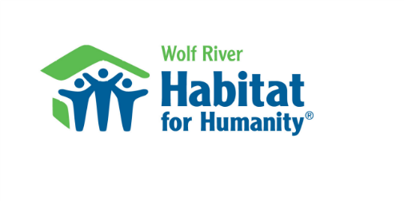
Construction Supervisor Job Description

Title: Construction Supervisor (3 Days per week- salaried position)
Reports to: Wolf River Habitat for Humanity (WRHFH) Board President
Employee Status: Exempt (salaried) at minimum 20 hours per week, must be available to work Saturdays as needed.
Salary and Benefits: Pay negotiable depending on experience. Work hours and schedule to be mutually agreed upon at hire. 12 days of personal time for full time position (which can also be used for sick days, starts after 90-day probation period). Employee is off on New Year’s Eve, New Year’s Day, Good Friday, Good Saturday, Independence Day, Thanksgiving, Christmas Eve and Christmas Day.
Overview: WRHFH is hiring a construction supervisor to oversee and coordinate the organization’s home building activities. The construction supervisor will work with employees and volunteers to build decent, simple affordable housing in partnership with selected families. We are seeking a dedicated individual who can grow our home building from 1 home to 2 homes per year. This goal will be directed by the board of director’s strategic planning process.
Responsibilities:
Operations: Increase affordable housing in Shawano and Menominee Counties. Building projects may include home renovations/remodels and accessibility projects as directed by the board.
- Oversee the entire home building process, including budget, permits, plans, materials procurement and coordination of volunteers and subcontractors.
- Work closely with the Construction Committee and Executive Committee.
- Participate in property acquisition and obtain competitive bids for materials and services. Be familiar and observe HFHI requirements and suggestions regarding building.
- Organize experienced volunteers to lead work groups.
- Plan each work day based on crew size and experience, required tools and materials.
- Perform warranty work after closing on property for the first year.
- Use in-kind material and labor when possible.
- Organize, inventory and maintain the affiliate’s vehicles, trailers and equipment.
Volunteer Engagement: Ensure a positive volunteer experience with the goal of retaining and growing volunteer engagement. Train partner families and volunteers to prepare them for days on the worksite along with future homeownership. The houses should not be built solely by subcontractors, the Construction Supervisor and a few select volunteers.
Promote Habitat Mission: Understand and demonstrate a thorough understanding of the Habitat mission: Seeking to put God’s love into action, Habitat brings people together to build homes, communities and hope. Ensure all volunteers, donors and construction professionals are familiar with the affiliate’s mission.
Safety: Enable the safety of volunteers and employees by ensuring that safety practices are followed on the jobsite and warehouse/store. Follow all WRHFH and Habitat policies. Maintain Habitat Competent Person certification for the affiliate.
Qualifications / Physical Requirements:
- A strong background in residential home construction with 3 years of supervisory experience preferred.
- Contractor’s license required, or the ability to obtain one.
- Commitment to Habitat’s ecumenical Christian ministry, ideals and philosophy.
- Excellent people skills since candidate will work with people of all ages, races, faiths, backgrounds and skill levels.
- Ability to establish a good working relationship with volunteers and homeowner families.
- Ability to work with minimal supervision.
- Physical Demands: Strenuous activity requiring ability to sit, walk, carry, push, pull, lift 100 lbs., climb, and bend.
- Ability to operate company vehicles, construction tools and equipment.
- Interest in teaching skills to volunteers and homeowner families.
- Successfully pass criminal background check.
- Must have basic computer skills including ability to use Word, email, internet.
- Must have a valid driver’s license and maintain a good driving record
- Completion of HFH Competent Person virtual training within 30 days after probation period.
To apply: Send resume to info@wrhabitat.org with the subject “Construction Supervisor”

